Ice and snow course on the Columbia Ice Fields and Ascent of Mount Athabasca

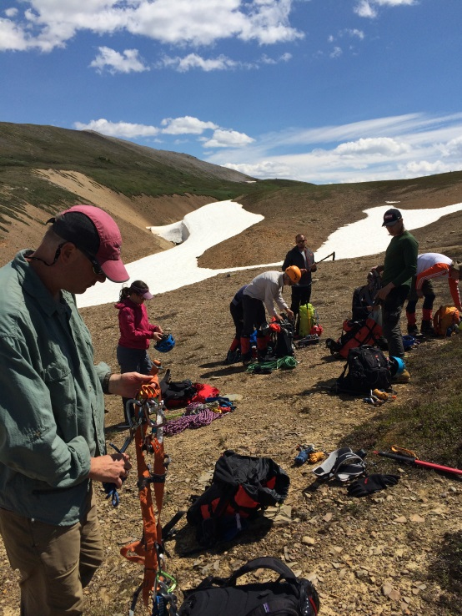
Our three day journey started on Saturday July 4th covering self-arrest with our ice axe, roping together and team crevasse rescue on the Park Ridge snow fields. Sunday had us on the Columbia ice field for more crevasse rescue, how to walk in crampons and use ice screws.

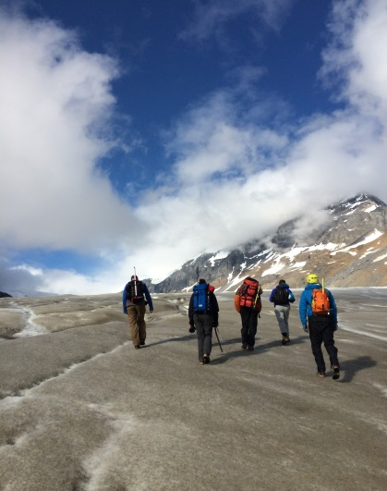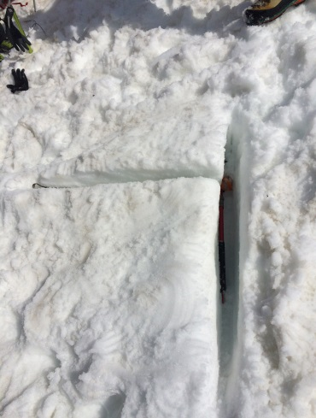

Our ascent of mount Athabasca started with an alpine start at 2:00 am on the western lateral moraine at the base of mount Athabasca where we climbed to a transition zone at the edge of the glacier.
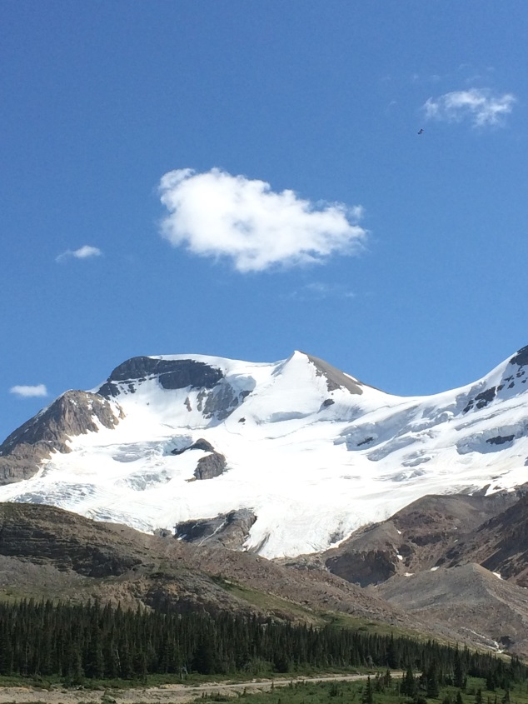
Here we placed on our crampons and began to traverse the Athabasca glacier under the silver horn. The traverse found us on the underside on the eastern edge of the silver horn at about 4:30 am where we witnessed a beautiful sunrise cresting above the Rockies. We then started our vertical ascent up the mountain before traversing across the ramp.

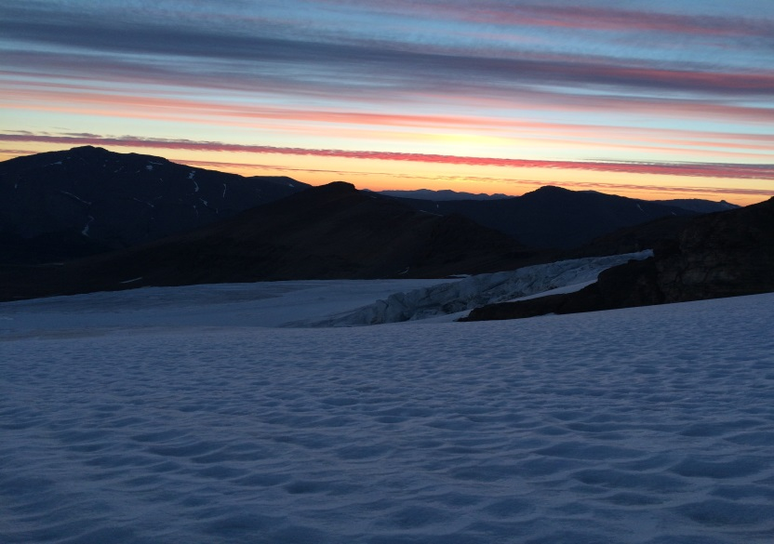

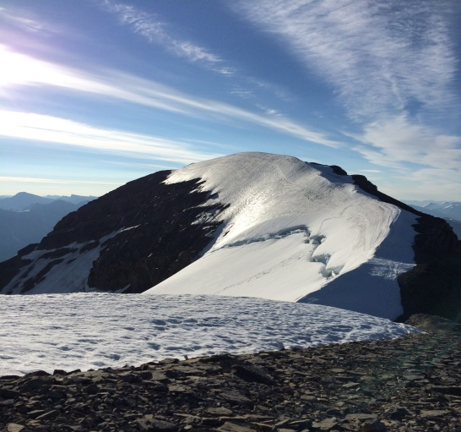
Our traverse across the ramp brought us to the base of silver horn. Near the top of silver horn the terrain shifted from ice and snow to lose shale making the climb a bit slippery with our crampons. No easy way to get through this section! At the top of silver horn we could see our destination the summit of Mount Athabasca and within 30 minutes we were standing at 11, 453 ft., (14th highest peak in the Canadian Rockies), on a mostly clear day and a 360 degree panoramic view of the majestic Rocky Mountains and Saskatchewan glacier. A few pictures and a snack and 15 minutes later we were heading down. The total round trip took us 9.5 hours and was a memorable experience worthy of such an early start.
